MAP 4C Mid-Term Exam Review
DO YOUR WORK IN YOUR NOTEBOOK. YOU MUST HAND IN ALL REVIEW ON EXAM DAY.

Unit 1 – Algebra

1. Expand and simplify.

a) (p – 4)(p + 5) b) (n + 8)(n + 2) c) (m + 3)(m – 7)

d) (w – 4)(w – 6) e) (2x – 3)(5x – 4) f) (y – 5)(2y + 9)

g) (3a + 1)(4a + 1) h) (7 – x)(4 + x) i) (x – 6)(x + 6)

j) (x + 2)2 k) (y + 11)(y – 11) l) (z – 5)2

2. Expand and simplify.

a) 4(x – 2)(3x – 5) b) (4x – 3)2 – 5(3x2 – 5x + 7)

3. Find an expression for the area of each shape.
4x - 1

5x 2x - 1

8x + 3

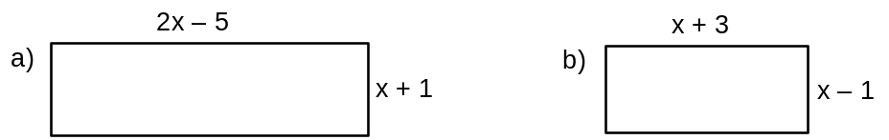

4.Factor each of the following completely. (Remember to follow the steps in your factoring chart.)

a) 18 – 12x b) 21w2 – 28w + 35 c) 24x2 + 16x d) 15a3 – 20a2 + 25a

e) 20m2 – 30m f) 27k3 – 36k5 g) n2 – 144 h) 81 – x2

i) 5m2 – 80 j) 10x2 – 90 k) x2 + 5x + 6 l) a2 – a – 30

m) x2 + 3x – 10 n) m2 – 9m + 20 o) x2 + 6x – 27 p) 3x2 – 6x – 105

q) 5x + 17x + 6 r) 5x – 7x – 6 s) 3x + 10x + 3 t) 2x + 9x + 4

5. Solve each quadratic equation.

a) x2 – 7x + 10 = 0 b) x2 – x – 12 = 0 c) x2 – 25 = 0

x2 – 3x = 10 e) x2 + 10x + 25 = 0 f) x2 + 81 = 18x

Unit 2 – Budgets

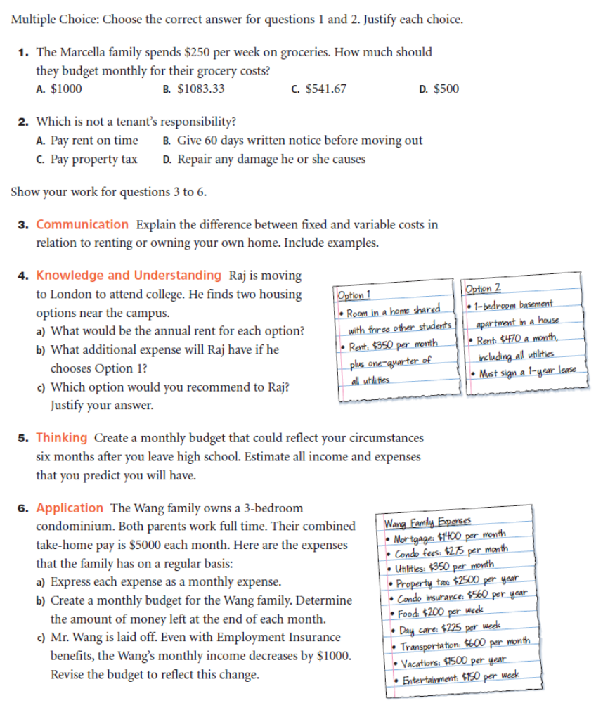
6. a) List two housing expenses that both renters and owners may have to pay.

b) List three expenses that only owners would pay.

7. Mark and Jen live in your community with their two children. They rent a three-bedroom apartment.

a) List the housing expenses that Mark and Jen would incur.

b) Estimate each monthly expense that you listed in part a for your community. Explain how you estimated.

8. Determine how much each housing expense will cost for one year.

- Weekly mortgage payments of $346.78

- Monthly phone bill of $29.95

- Monthly rent of $765

- Bi-annual insurance bill of $427.60

- Quarterly water heater rental of $68.95

9. Ivor estimated his monthly housing costs. Calculate the total cost for one year.
Rent monthly $950.00
Insurance bi-monthly $35.00
Cable/Internet monthly $95.00
Electricity monthly $45.00
Furniture semi-annually $750.00
You have been given a budget table for this.

Units 3 & 4 – Trigonometry & Measurement

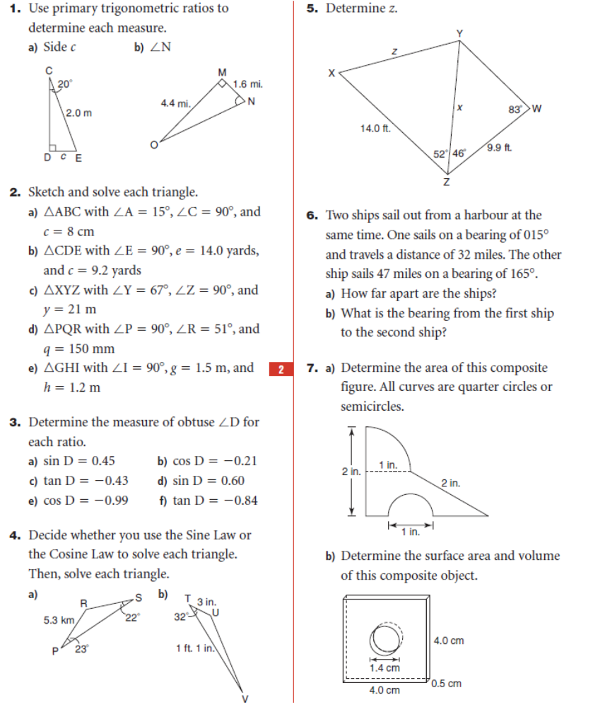

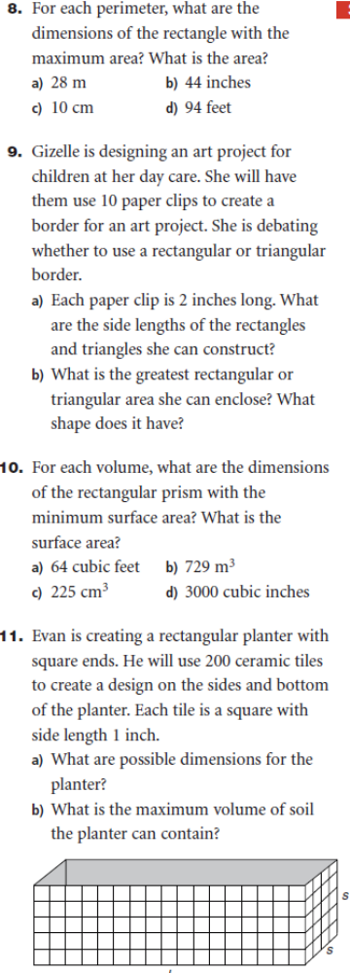

ANSWERS Units 3 & 4
ANSWERS

Unit 1
1. a) p² + p – 20 b) n² +10n + 16 c) m² – 4m – 21 d) w² – 10w + 24
e) 10x² – 23x + 12 f) 2y² – y – 45 g) 12a² + 7a + 1 h) –x² + 3x + 28
i) x² – 36 j) x² + 4x + 4 k) y² – 121 l) z² – 10z + 25 2. a) 4x² – 44x + 40 b) x² + x – 26 3. a) 2x² – 3x - 5 b) 28x² - x – 4
5. a) 2 or 5 b) 4 or -3 c) 5 d) 5 or -2 e) -5 f) 9

Unit 2

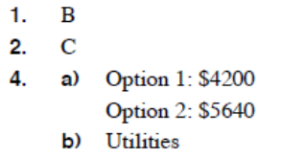
6. a) Electricity, gas, water, TV/cable, phone, internet
b) Property tax, home insurance, mortgage, maintenance
7. a) Rent, cable, phone, internet, utilities
8. a) $18 032.56 b) $359.40 c) $9180 d) $855.20
e) $275.80 9. $14 790

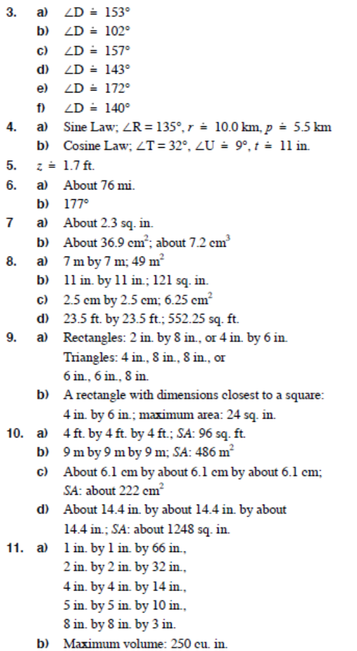
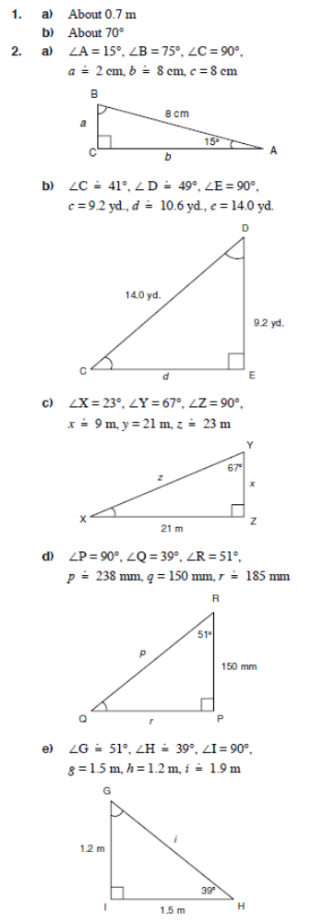

BUDGETS REVIEW QUESTION 5
Budget Item | Monthly Amount ($)
INCOME | Fixed | Variable | Total
Total Income
EXPENSES
Total Expenses
Total Income – Total Expenses

